



ADGES UI COMPONENTS LIBRARY

**Component ID #1 – ex-accordion - v1.1.0**

## Document Control

## Version History

|  |  |  |  |
| --- | --- | --- | --- |
| Version | Date | Author | Reason for Change |
| 1.0.0 | 10/24/2019 | Wael Gomaa |  |
| 1.1.0 | 09/22/2020 | Rijin Mukundan |  |
|  |  |  |  |
|  |  |  |  |
|  |  |  |  |
|  |  |  |  |
|  |  |  |  |
|  |  |  |  |

## Review History

|  |  |  |
| --- | --- | --- |
| Version | Reviewer | Date |
|  |  |  |
|  |  |  |
|  |  |  |
|  |  |  |
|  |  |  |
|  |  |  |
|  |  |  |

Table of Contents

Document Control 1

Version History 1

Review History 1

1. Document and components Purpose. 3

2. General Information. 3

3. How to use. 3

4. Component features and configure. 4

5. How to configure the component. 4

6. Examples 4

# Document and components Purpose.

The purpose of the document is to guide how to use and configure the **ex-accordion** component.

# General Information.

Component Name: Accordion.

Extension Theme: ex-accordion.

Owner: Wael Gomaa.

Version no: v1.1.0

**Design**

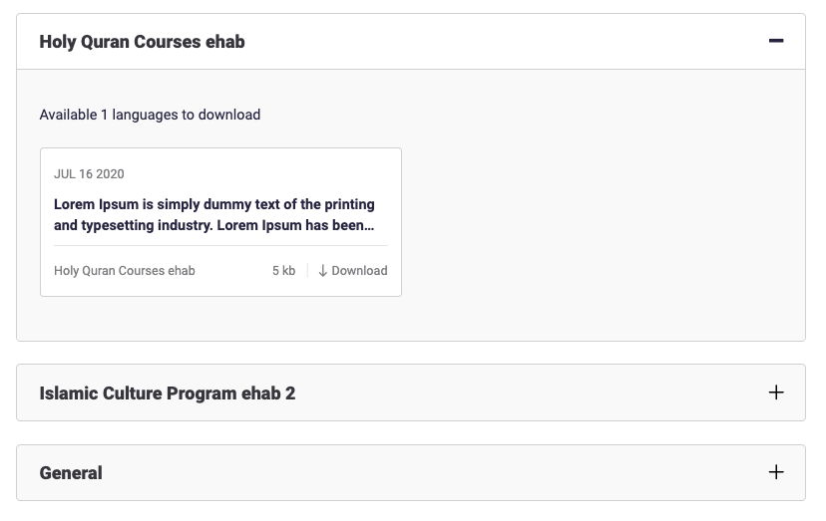

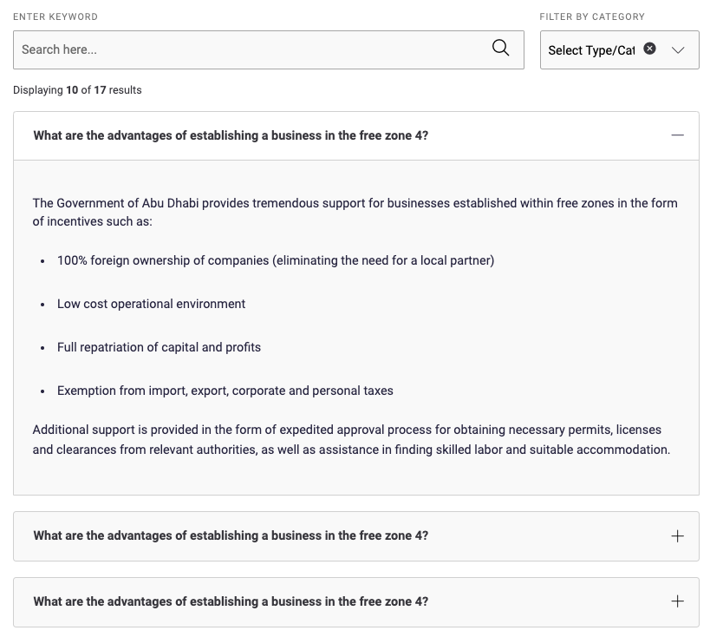

# How to use.

1. The available commands for this project .
   1. Compile : npm run gulp compile -- –path ex-accordion –extension
   2. Compile & include under ADGE tenant : npm run gulp compile -- –path ex-accordion –extension –full –dest [ADGEFolder]
   3. Deploy : npm run gulp deploy -- –path ex-accordion –extension
2. *Now project have full copy from this extension theme under the project theme and you can apply the project brand guideline and configure component based on project needs.*

# Component features and configure.

You have access now to configure the component with the below item.

$accordion-bg-color : $grey-50 !default;

$accordion-transition-time : .4s !default;

$accordion-item-border-color-alt : $grey-200 !default;

$accordion-item-icon-font-size : 21px !default;

$accordion-item-bg-alt : $grey-200 !default;

$accordion-item-border-color-alt-hover : transparent !default;

$accordion-item-border-radius:4px !default;

$accordion-item-bg-alt-hover : $white-color !default;

$accordion-item-border-color : $grey-200 !default;

$accordion-item-border-size : 1px !default;

$accordion-item-min-height : 62px !default;

$accordion-item-strip-color : $primary-color !default;

$accordion-item-strip-width :0 !default;

$accordion-item-trigger-color : $black-color !default;

$accordion-item-content-color : $primary-color4 !default;

$accordion-item-content-bg: $grey-50 !default;

$accordion-item-content-line-height : 26px !default;

$accordion-item-expanded-bg-color : $white-color !default;

$accordion-item-expanded-border-color : $grey-200 !default;

$accordion-item-expanded-border-radius : 4px 4px 0 0 !default;

$accordion-item-expanded-trigger-color : $primary-color4 !default;

$accordion-item-img-height:50px !default;

$accordion-item-img-width:100px !default;

$accordion-item-header-line-height:1.5 !default;

$accordion-item-header-title-color:$grey-900 !default;

$accordion-item-header-title-font-size : 16px !default;

$accordion-item-header-title-pading : 62px !default;

# How to configure the component.

There are various ways to configure the component:

1. **CSS Class / Data Configuration (on the variant)**

**CSS Class Configuration Method**

These styles can be applied in the variant to get the desired result

|  |  |  |
| --- | --- | --- |
| Feature | Modifier | Default value |
| Alternative view without grey background | ex-accordion--alt |  |

**Data Attribute Modifiers**

These attributes can be applied in the variant to get the desired result

|  |  |  |
| --- | --- | --- |
| Feature | Modifier | Default value |
| Adds active class | data-active-class | expanded |
| Adds class “show” to the first accordion item | data-showfirst |  |

1. **Adding Built-In or Bootstrap Class (on the variant)**
   1. Spaces, Font weights, Display, Position properties etc can be added by bootstrap classes
      1. i. Spacing: <https://getbootstrap.com/docs/4.0/utilities/spacing/>
      2. ii. Flex: <https://getbootstrap.com/docs/4.4/utilities/flex/>
      3. iii. Font: <https://getbootstrap.com/docs/4.0/content/typography/>
   2. These classes should only be added to match the design
   3. For built-in classes check 7 Below to see the entire list
2. **SCSS Variable Override (on the _override.scss file)**

To configure the component we can take the above variables from section **4. Component features and configure** and add them to: adge-ph2/themes/<ADGE>/vars/_override.scss, this file with your desired changes to match the design.

1. **Complete style override**
   1. This should be the last and final option if the above 3 didn’t get you the desired output
   2. This is overwriting the SCSS of the component by adding your own style to it
   3. **Note: Take permission before doing this override**
   4. Instructions:
      1. Open the file /adge-ph2/themes/<ADGE>/sass/overrides.scss and add your own SCSS styles to override the faulty component.

# Dependencies

1. ex-layout
2. ex-main-theme

# Examples

Examples1:

I need to change the text color.

I’ll copy the below variables from the extension theme.

$highlight-main-tittle-color: $primary-color;

Then will paste the above variable in the project folder theme in file _override.scss and change with any variable based on-site needs.

$highlight-main-tittle-color: $secondary-color;

Examples2:

I need to the button shape from square to had a rounded corner.  
I’ll copy the below variables from extension theme.

$button-shape-square: $border-radius-value;

$border-radius-value: 0px;

Then will paste the a above variable in project folder theme in file _override.scss and change with any variable based on site needs.

$button-shape-square: $border-radius-value;

$border-radius-value: 20px;

# Artifacts

Purpose of the accordion component to show detail of item when user click on it. We can use it with image and without image or with grey background and simple white background.

# List of Built-In classes

**For Fonts:**

caption

big-slogan

font-italic

text-nowrap

text-white

small-text

**For Buttons:**

button--large

button--medium

button--small

button--secondary

button--tertiary

**For Dark Mode:**

high-contrast--forced

high-contrast—reset

**General:**

stretched-link

section—white

rounded

rounded-top

rounded-right

rounded-bottom

rounded-left

rounded-circle

rounded-5